Lab 3: Using EF Core CLI to Create and Apply Migrations
Scenario: The retail store's database needs to be created based on the models you've defined. You’ll use EF Core CLI to generate and apply migrations.

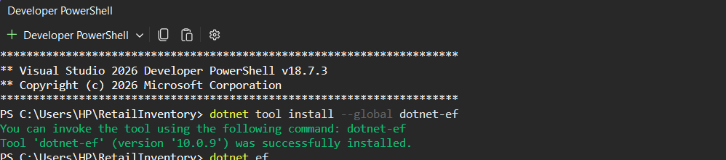
- Install EF Core CLI (if not already):

- Create Initial Migration:

- Apply Migration to Create Database:

- Verify in SQL Server:

